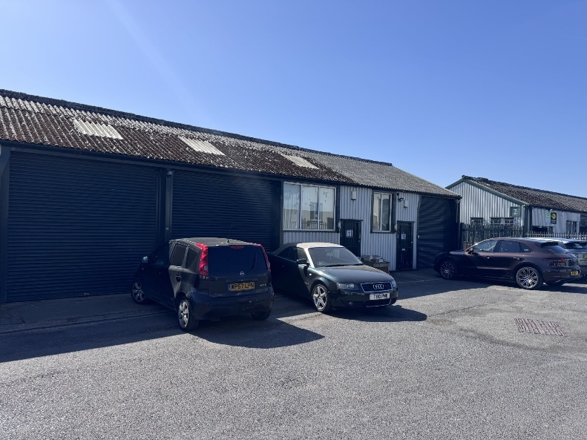 |  | 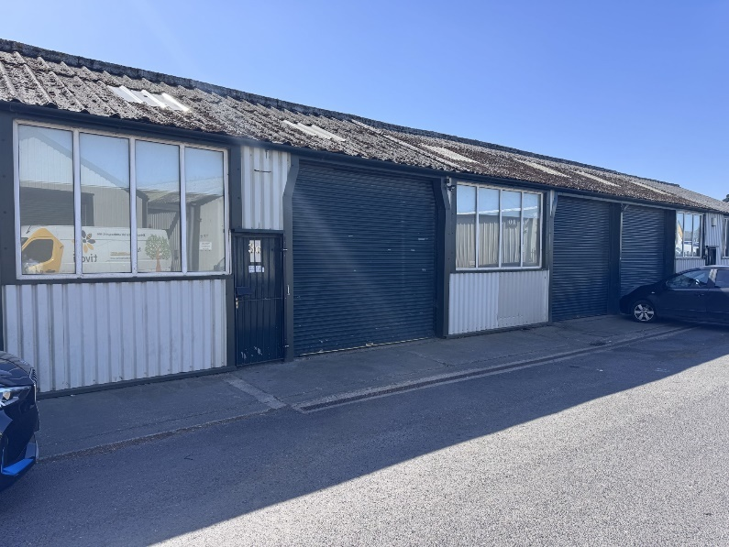
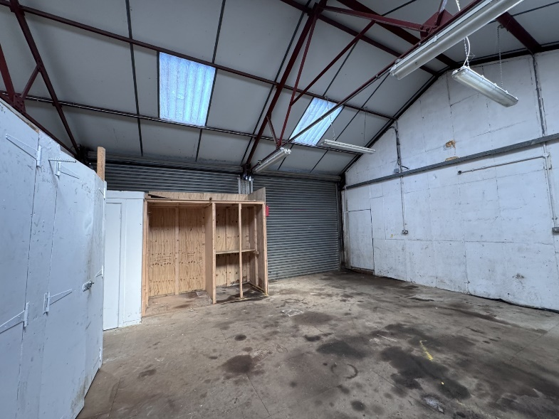 |  | 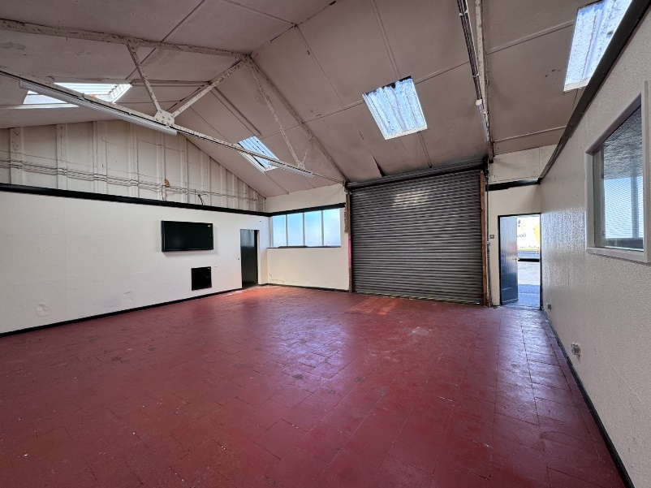

TO LET UNITS 3A, B & C CLIFTON BUSINESS PARK PRESTON NEW ROAD CLIFTON PRESTON PR4 0XQ

Single storey workshop/light industrial units with offices ranging from 824 ft² to 2,134 ft²

- Well established and popular business park, close to Preston’s Riversway Docklands estate and within close proximity to the Edith Rigby Way, which affords easy access to the M55 and the national motorway network.
- On-site car parking and servicing areas
- Roller shutter loading doors. Three phase power supplies. Office facilities with air conditioning.

Location

Clifton Business Park fronts Preston New Road, a short distance from Preston’s Riversway Docklands estate and the Edith Rigby Way.

Well located within easy reach of the M55 and national motorway network and Preston, Lytham and Blackpool.

Description

Single storey wareshop/light industrial units, with office facilities.

Roller-shutter access doors 10’11 wide x 10’3 high.

Accommodation

Units 3A & B 1,310 ft².
Unit 3C 824 ft².

The office facility within Units 3A & B has the benefit of air conditioning.

Assessment

The units are entered on the rating list as under:-

Units 3A & B £8,100

Unit 3 C £6,000

Rates payable 20124/2025: 49.9p in the £

Small business rate relief available.

Services

The units have the benefit of a three phase power supply. Toilet facilities are provided within Unit 3A & B and communal WC facilities are available elsewhere on the site.

Lease

The premises are available on three year leases, or multiples thereof, upon standard full repairing and insuring terms.

Service Charge

A service charge will be levied for expenses incurred in connection with the maintenance of the common parts and the site’s sewerage system..

EPC

A copy of the EPC is available from the agent’s office.

Rental

Units 3A & B £15,000 pa
Unit 3C £ 6,500 pa
Units 3A, B & C as a single unit £20,000 pa

VAT

Rental and service charge payments are subject to VAT at the prevailing rate.

Legal Costs

Each party are to be responsible its own legal costs involved in the transaction.

Viewing

Strictly by appointment through the agents HDAK. Telephone: 01772 652652 or e-mail: reception@hdak.co.uk

